**2025 Season**

**TELL TIMAI**  
Location: EGYPT  
Seasons (All Dates are Tentative) (partial seasons of at least 2 weeks are fine):

Season: June 15 – July 2025

**Application Deadline**

**Sept 20, 2024**

**Program Type**  
Geophysical Survey/Lab Analysis/

Excavation/Conservation

**Affiliation**  
Nottingham Trent University, UK

University of Hawaii, USA

**Project Directors**  
Dr. Jay Silverstein, Nottingham Trent University

Prof. Robert Littman, University of Hawaii

**Description**

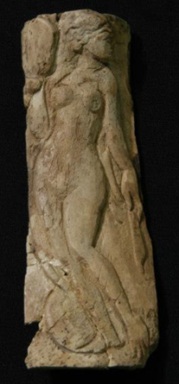A call for archaeologists, participants, and a few supervisors interested in the Winter 2024 and/or Summer 2025 archaeological study of the site of Tell Timai in the Nile Delta region of Egypt.

The ruins of the Greco-Roman Egyptian city of Thmouis are found at Tell-El Timai in the Nile Delta of Egypt near the modern city of El-Mansoura. Thmouis is first mentioned in Classical texts by Herodotus (*Histories of Herodotus* 2.166) based on his visit in the middle of the 5th century BC. By Ptolemaic times the city was flourishing, having assumed administration of the Mendesian nome from its sister city at nearby Mendes. Historical references to the city in Josephus (*Jewish Wars* 4.656), Pliny (*Natural History* 13.2.4), Ammianus Marcellinus (*Roman History* 22.16), and other sources attest to the importance of the city in the Classical world. The city earned its greatest fame as the source of Mendesian perfume prized throughout the Mediterranean. The city played an important role in the rise of early Christianity, serving as an episcopal see during the Late Roman Period (3rd - 4th centuries AD). The city appears to have been abandoned during the Arab Period in 831 AD following the suppression of a tax revolt. The coming season will be focused on the Rise of Christianity and Roman monumental architecture.



**See photos of previous seasons:** <http://www.flickr.com/photos/31110069@N02/sets/72157607743111893/>

**See Video Blog**:

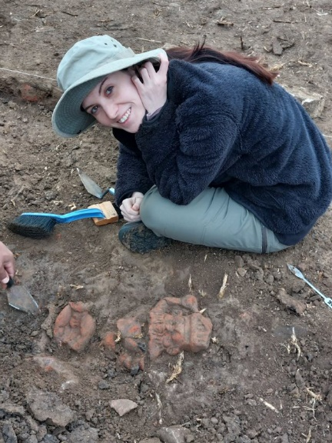<http://www.biblicalarchaeology.org/media/video/video-tell-timai-2014-week-two/?mqsc=E3775204&utm_source=WhatCountsEmail&utm_medium=BHD+Daily%20Newsletter&utm_campaign=E4B703>

**In The News:**

[**https://www.theartnewspaper.com/2023/01/27/where-the-swords-met-bone-archaeological-evidence-found-of-ancient-egyptian-rebellion-mentioned-on-the-rosetta-stone**](https://www.theartnewspaper.com/2023/01/27/where-the-swords-met-bone-archaeological-evidence-found-of-ancient-egyptian-rebellion-mentioned-on-the-rosetta-stone)

[**https://www.livescience.com/rosetta-stone-ancient-egyptian-battle-site**](https://www.livescience.com/rosetta-stone-ancient-egyptian-battle-site)

[**https://www.hawaii.edu/news/2019/07/30/cleopatras-perfume-recreated/**](https://www.hawaii.edu/news/2019/07/30/cleopatras-perfume-recreated/)

**Web Site:**

[**http://www.telltimai.org/**](http://www.telltimai.org/)

**Period(s) of occupation**  
ca. 450 BC - ca. 831 AD

**Minimum length of stay for participants**   
2 weeks

**Experience required**  
Archaeology courses/experience preferred but not required.

**Room and Board Arrangements**  
Participants pay their own costs (Dig Fee). Air transportation to Cairo is not covered by this fee. All in-country costs are covered except incidentals and non-project hotel stays. A number of partial scholarships are available. For costs and details contact Dr Robert Littman ([littman@hawaii.edu](mailto:littman@hawaii.edu)),

The Dig House for the project is located in the adjacent town of Timai El Amdid and all basic amenities are available there. House rooms are generally shared by 2 to 3 people. Each floor of the Dig House has a bathroom with a heated shower. A cook is retained by the project as is a cleaning staff.

**Application Process**

Email Robert Littman littman@hawaii.edu

**Academic credit**  
Academic credit is not offered directly for participation, but the directors will work with those enrolled in university courses to meet the requirements of that student’s university for independent study.

**Contact information**

Stacey Bagdi, Project Manager

[telltimai2022@gmail.com](mailto:telltimai2022@gmail.com)

Professor Robert Littman, Co-Director

[littman@hawaii.edu](mailto:littman@hawaii.edu)

Dr. Jay Silverstein, Director

[Jay.silverstein@ntu.ac.uk](mailto:Jay.silverstein@ntu.ac.uk)